**OS Homework 1**

1. kernel compilation

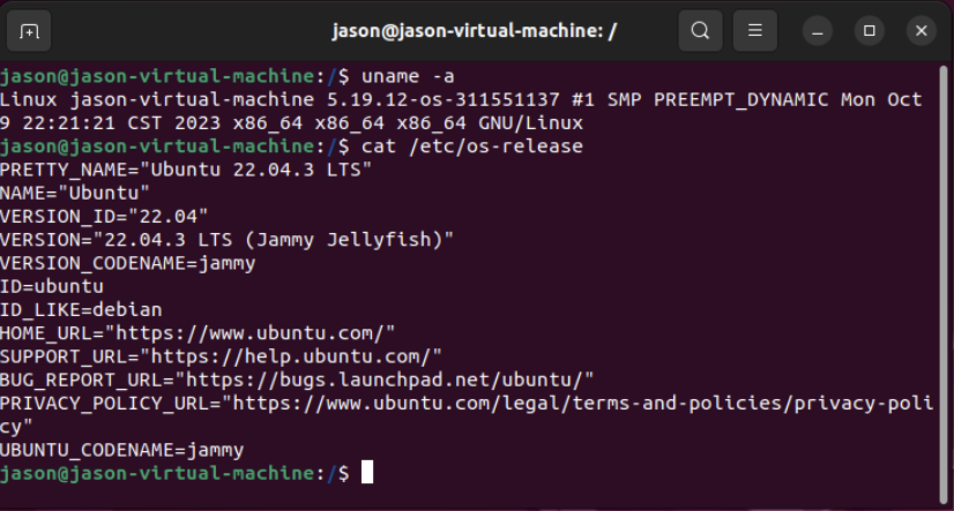

2. system call

- Describe how you implemented the two system calls in detail.

- Which kernel sources did you modifiy? What do they do?

- For each system call you implemented:

- Paste the **well-formatted** source code into the document.

- Paste the screenshot of the messages the system call printed.

a. Steps for implementing sys_hello:

1. cd ~/linux-5.19.12

2. mkdir

3.

- Add hello.c

- Add the corresponding function prototype for the new entry point in include/linux/syscalls.h:

asmlinkage long sys_hello(void);

#include <linux/kernel.h>

#include <linux/syscalls.h>

SYSCALL_DEFINE0(hello)

{

printk(KERN_INFO "Hello, world!\n");

printk(KERN_INFO "311551137\n");

return 0;

}

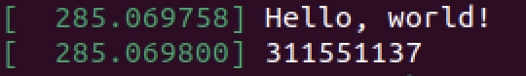

b. sys_revstr